# Climatology

Rwanda’s climate

Average temperature and rainfall by region

Decadal bulletins

Climate change in Rwanda and the region

# Rwanda’s climate

The Republic of Rwanda is a landlocked country situated in east-central Africa, surrounded by the Republic of Congo, Uganda, Tanzania, and Burundi.

It is a country with a total area of 26,338 square kilometres of grasslands, small farms extending over rolling hills and areas of steep mountains and deep valleys southeast that extend from a chain of volcanoes in the northwest. Lake Kivu in the northwest at an altitude of 1,472 metres is the highest lake in Africa. Extending north of the Lake are the Virunga Mountains, which include the volcano Karisimbi at 4,324 metres as the highest point in the country.

Rwanda lies 30 degrees south of the equator and would therefore be expected to have the climate of equatorial rain forest. However, because of the country’s high altitude (1,400 ft) the climate of Rwanda is characterized by mild temperatures throughout the year.

The main synoptic scale system controlling rainfall in Rwanda is the Intertropical Convergent Zone (ITCZ). This displays two distinct branches – the meridional and zonal that tend to be quasi stationary in the region during rainy season. The meridional arm seems to be dominant of the two over the country with westerly lower Tropospheric winds bringing in the Congo Airmass.

There are two rainy seasons March to May and September to December, with heavy down pours occurring almost daily, alternating with sunny weather. The dry seasons between June and August and January and February are characterized by sunny days and cool nights. Average annual rainfall is 800mm.

**General climate in Rwanda by month**

|  |  |
| --- | --- |
| **Month** | **Climate** |
| January |  |
| February |  |
| March |  |
| April |  |
| May |  |
| April |  |
| June |  |
| July |  |
| August |  |
| September |  |
| October |  |
| November |  |
| December |  |

**-------------------------------------------------------------------------------------------**

**Average temperature and rainfall by region**

|  |  |  |
| --- | --- | --- |
| **Month** | **Average Temperature (oC)** | **Average Rainfall**  **(mm)** |
| January |  |  |
| February |  |  |
| March |  |  |
| April |  |  |
| May |  |  |
| April |  |  |
| June |  |  |
| July |  |  |
| August |  |  |
| September |  |  |
| October |  |  |
| November |  |  |
| December |  |  |

**-------------------------------------------------------------------------------------------**

**Decadal bulletin**

Explanation

**-------------------------------------------------------------------------------------------**

**Extreme weather in Rwanda**

Severe weather which affects Rwanda includes droughts, storms and flooding.

The frequency of such events is increasing, with devastating impacts on lives and property.

Over the next 2 years, RMS will be developing an early warning system with other stakeholders such as REMA and the Ministry of Disasters and Emergencies. Through accurately forecasting severe weather and communicating warnings communities and government can take action to minimize its impacts.

**Droughts**

Droughts/floods/storms are a major problem in Rwanda. They range from light to moderate to severe levels. Every year, there is a drought/flood/storm in any one locality of the country caused either by spatial variability of rains, by synoptic weather systems that may influence low/heavy rains in the area or a mismanagement level of environmental. The highly erratic nature of current rains is also linked to global warming some extent.

The recent drought that forced the government of Rwanda to declare a state of emergency occurred in 2006. Although it is hard to correlate changes in climate with frequency of occurrence of droughts, the rising number of dry spells and drought situations have become more common and unmanageable in recent years, mainly because of a lack of preparedness.

**Major droughts occurred in the following years:**

A severe drought of untold proportion occurred in the La Niña years of 1998/99 when it was felt across the whole the country. There were massive crop failures in many parts of the country, which resulted into widespread famine. Water shortage in reservoirs such as Burera and Ruhondo inland lakes caused water and energy rationing since 1999 and persisted up to now. Energy and Agricultural outputs have continued to decline noticeably, making the region suffer wide spread fits of food insecurity and the cost of hydro power for industries has become prohibitively expensive. Moreover, those intending to invest in agriculture are increasingly becoming risk averse due to droughts variability trends.

**Forecasting droughts**

Drought cycles and frequency exhibit temporal patterns of varying degrees and highly skilled forecasters are needed to detect these in the weather and climate models. They must also be scrupulous in gathering the right type of information gathering, information analysis and the refinement of the weather or climate products about the drought possible occurrence and severity. The basic infrastructure needed for this kind of work is broad indeed. Meteorological observations from the land stations must be enough and representative of the area of concern, together with this data is the information from satellites and from the models about the interaction of mesoscale, synoptic scale systems evolution and their teleconnections. It is through this art of study, that an experienced forecaster is able to detect early signals of drought or a flood or any other meteorologically related severe hazard. Rwanda Meteorological Service currently lacks such competency. The EWS strategy should therefore outline how this gap can be filled. The need for training in NWP and use of NWP models is anticipated.

**Storms**

In recent years, incidents of disaster caused by heavy thunderstorm and gale winds are occurring in the early months of rainy seasons. Each year, heavy rains and gale force winds wreck different districts around the country by destroying houses, schools and other community-based infrastructure. On the 19th, October 2008, the damage caused in KIREHE district alone, was estimated to be about 416 million Rwandan francs. This is roughly the average annual loss since 2008 (report of National disaster centre of Rwanda). In March 2010, 6 school children were killed when a roof was blown off a house in heavy wind. in the months of February and early march of this year (2011), many hoses and schools in Nyagatere and Bicumbi districts were destroyed by heavy storms associated with gale winds and hailstones in some cases.

**Forecasting storms**

Forecasting a storm strength and speed including its possible direction is possible but not easy! Storms are essentially thermally induced, mesoscale features, they exhibit destructive nature of hailstones, violent winds and high intense rainfall but which in most cases last for a short duration (10 to 30 minutes) at most. A forecaster needs to understand the potential for supercell formation and development, skills to predict the potential of its occurrence.

**Floods**

Flash floods are very common in northern parts of the country. They result mainly from heavy downpour over a short period during the rainy seasons. Flooding is also caused in Rwanda by environmental mismanagement, such as the careless blocking of waterways.

A major flood in recent history was observed during the El niño years of 1997/98. This had far reaching socio-economic consequences

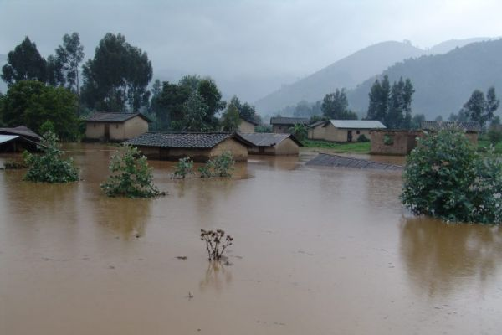

Flooding which first took place in the Rubavu district in 2007 has now become an annual event. Every year, flash floods destroy houses, and many human lives including their animals are lost.

The construction of buildings and tarmac surfaces at raised gradients (this is common in Kigali for example) have encouraged more surface runoff than ever before and thus frequent flooding and landslides (e.g. in the Nyabugogo valley of Kigali).

**Forecasting floods**

Forecasting of floods is challenging. Most of floods in Rwanda are due to convective mesoscale systems which require ingenuity and experience of a sober forecaster. Such convective systems are associated with high precipitation and the forecaster needs to be able to estimate the duration of this rain, the specific location, its intensity and whether it is associated with some super cells that are likely to continually develop in motion with the precipitation. Weather radar would be the best tool to use for this. Hydrologists could also have modelling tools tailored to this kind of forecasting but, there is no current collaboration between the forecasters of RMS and the Hydrological unit of MINIRENA.

Earthquakes and volcanic eruptions are also natural phenomena which have a devastating impacts on Rwanda. The responsibility for earthquakes..